Start admin console
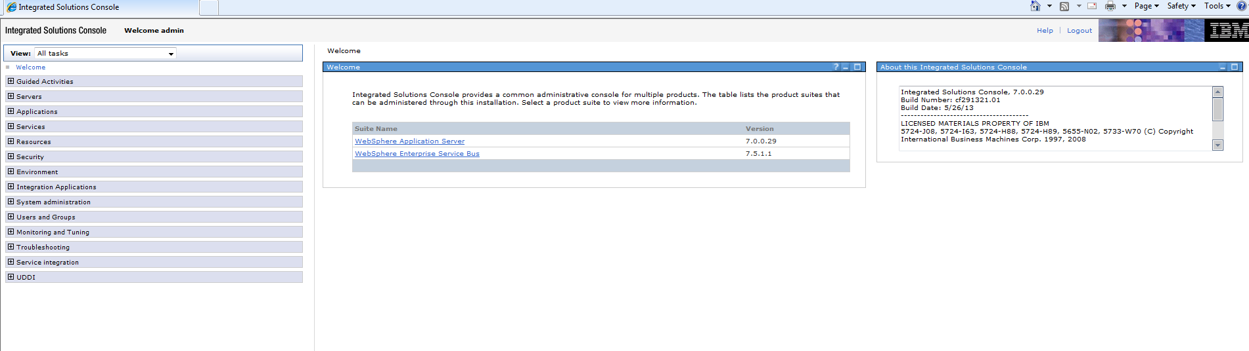
Select Resources > JDBC > Data Sources
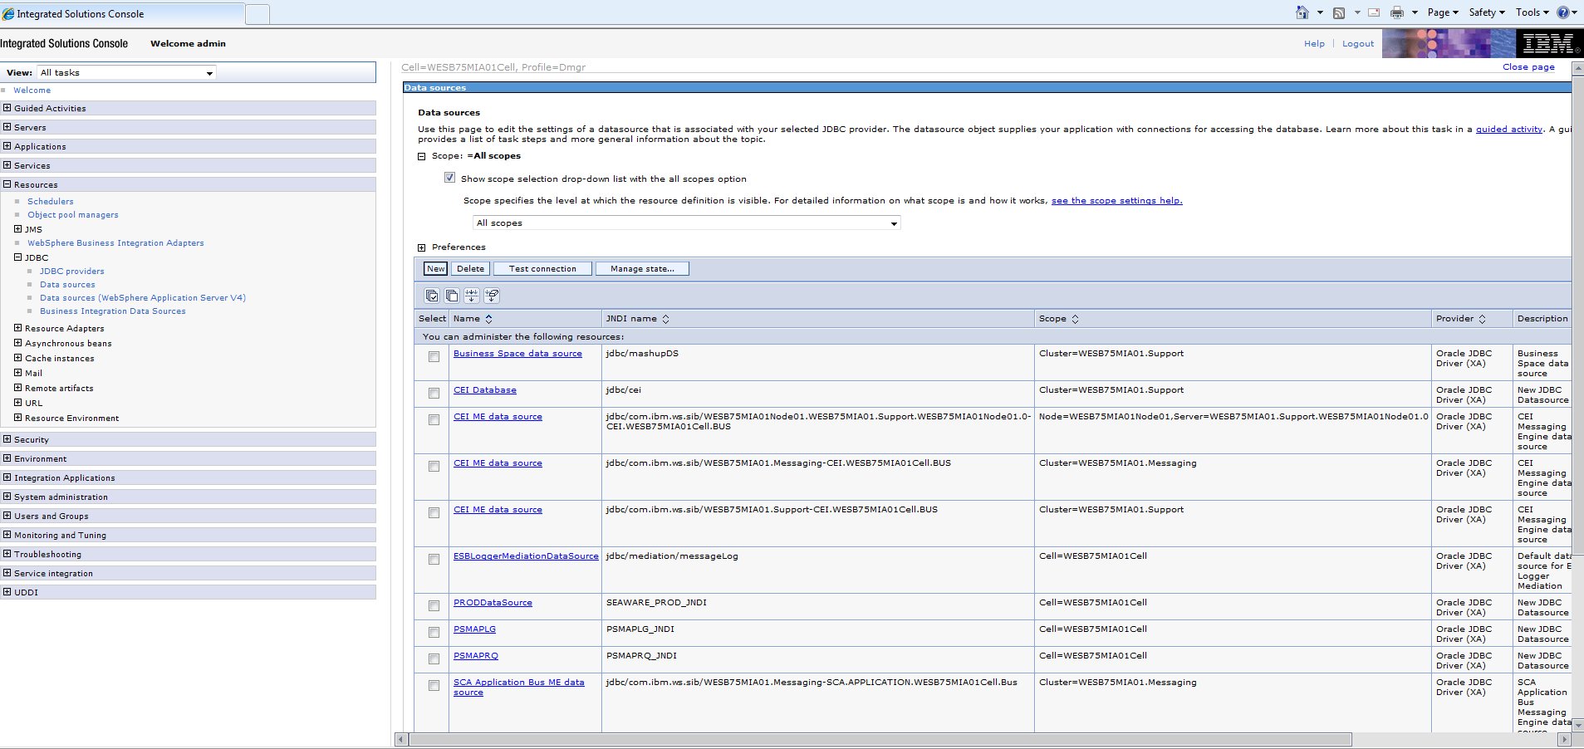
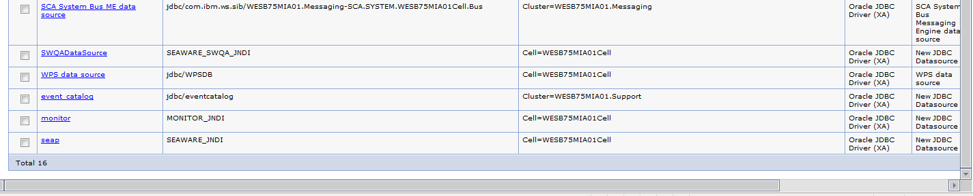

Verify each of the datasources is pointing to the correct database 167.118.127.50 SEAP. Example SEAP
Select SEAP from the list of datasources.
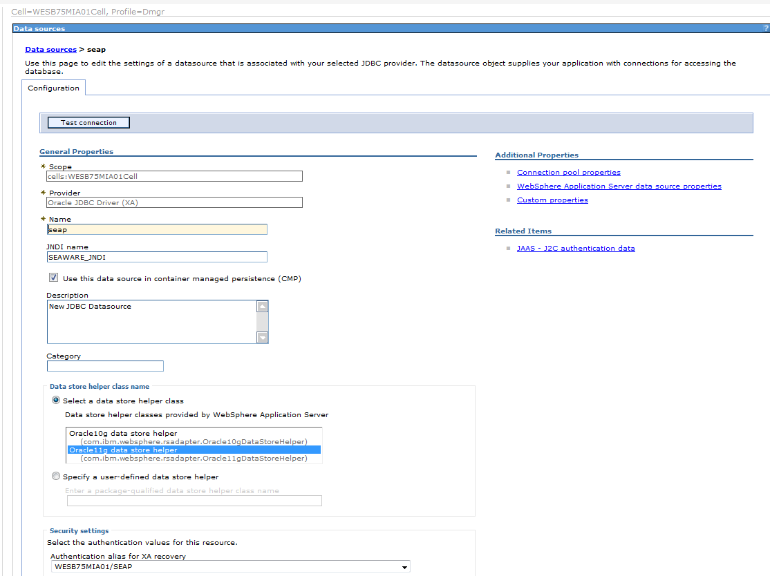
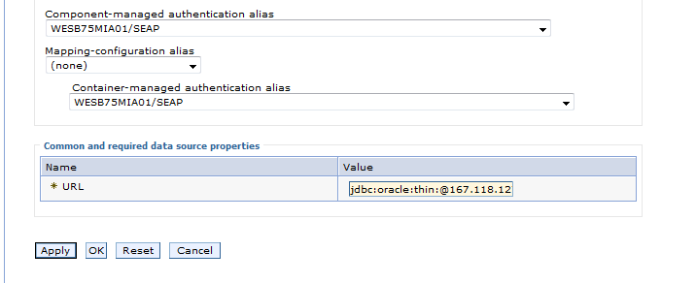
Change/verify the Value to the desired URL. Currently it is probably pointing to SEAT
jdbc:oracle:thin:@167.118.127.60:1521:SEAT
It should point to SEAP, jdbc:oracle:thin:@167.118.127.50:1521:SEAP, though verify with the DR coordinator or the DBA team.

Test connection for each Data source. On the Data sources screen, select the check box of the desired data source and press the Test connection button. The result at the top of the screen should be:
The test connection operation for data source seap on server dmgr at node WESB75MIA01 was successful.
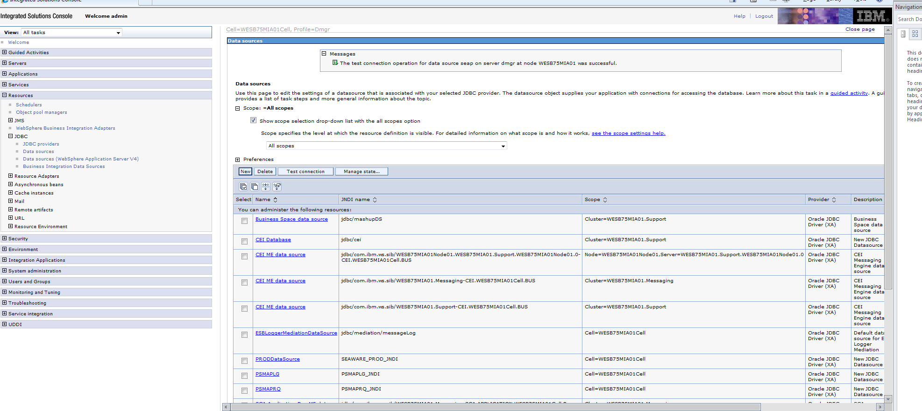
If there is a problem with the password for the Data source, the password can be edited by selecting
Data sources > seap > JAAS-J2C authentication data
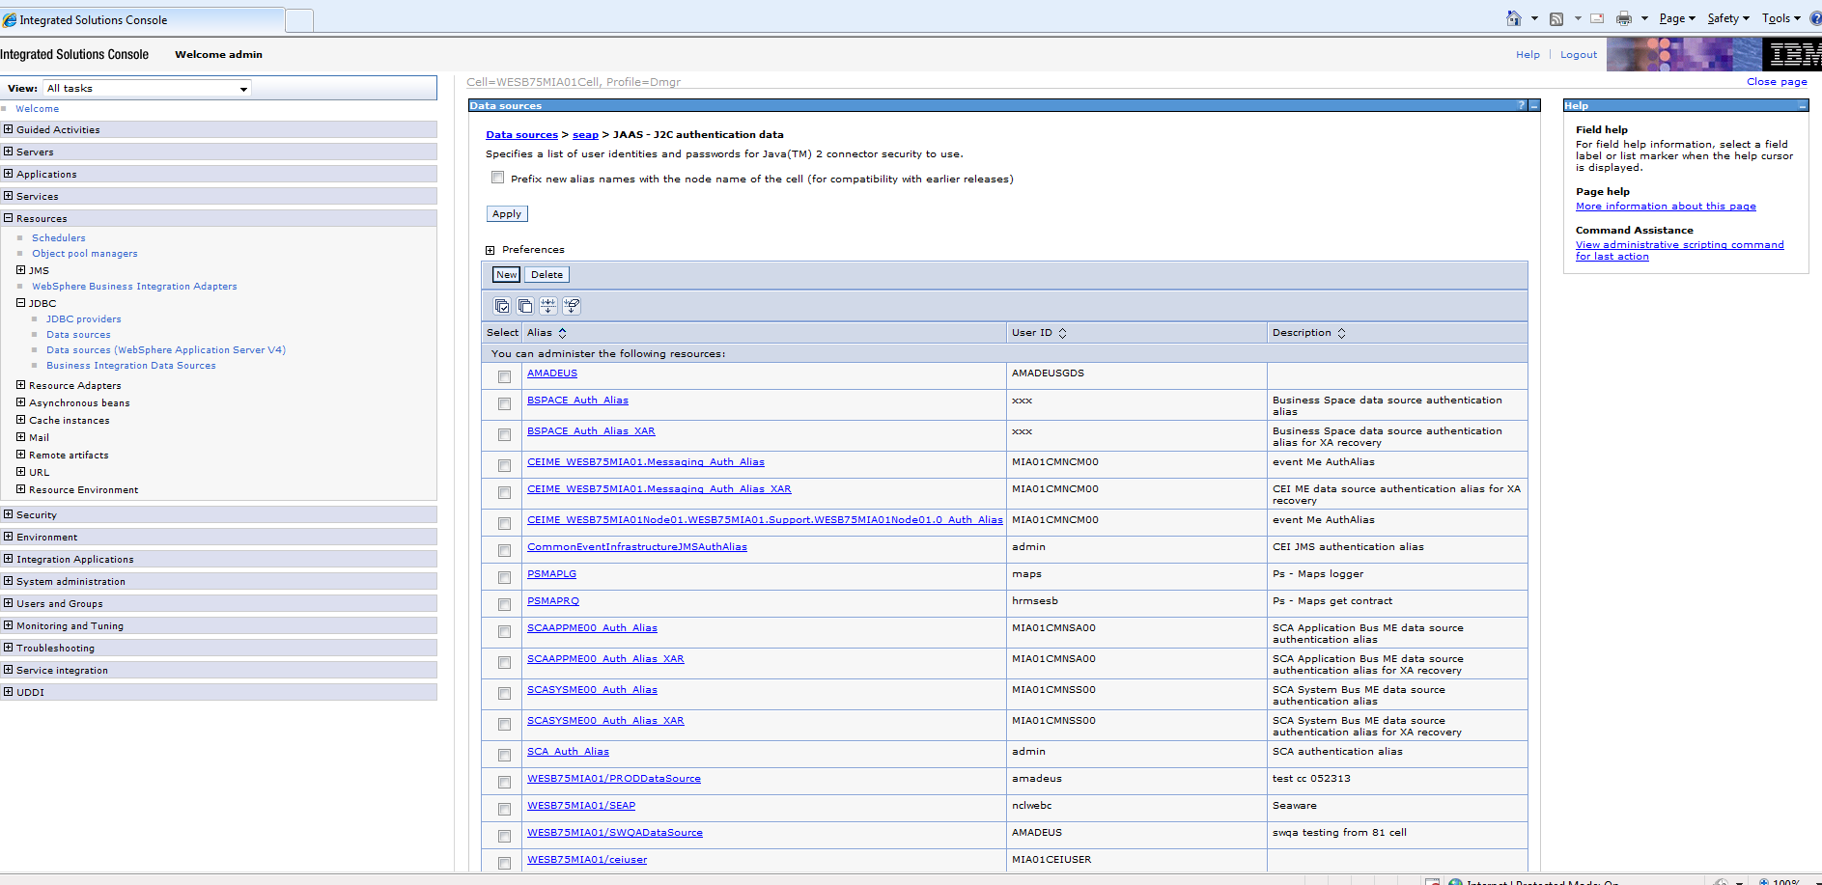
Select the desired preference. Example WESB75MIA01/SEAP
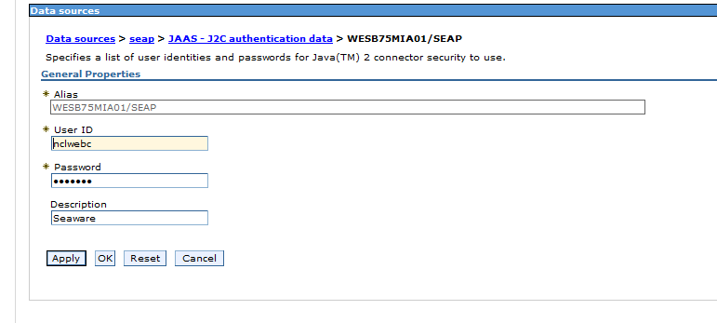
Enter the correct Password and press OK
Now you can re-test the connection

